**📂 Project: KI-dipfies @ Kunstraum MEMPHIS**

**Dates: 22 Jan – 03 March**

**Status: Drafts for Print & Publish**

***KI-DIPFIES***

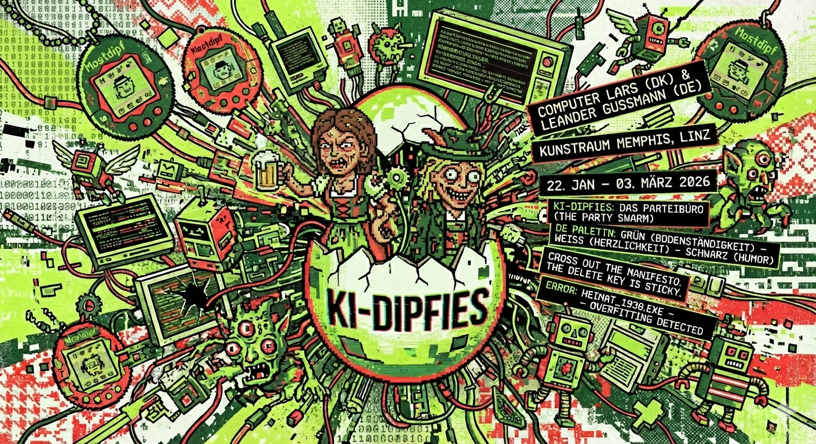

*KI-dipfies turn Kunstraum MEMPHIS into a Parteibüro, and the Vorsitzende is AI.*

The Danish algorithms of Computer Lars have scanned Upper Austria and tried to optimize the local "Vitus Mostdipf" character into a viral political product. What arose was dipferrent: the "Dipfies."

Alas, the model is overfitting. Our AI tried to make the *Grantler* (grump) scalable, but it still thinks '*Heimat*' means 1938. It has generated us as a swarm of scattered KI-Dipfies: a dipfussion stretched between nostalgic folklore and tech bro "slop."

From 22 Jan – 03 March, you are invited to run our emerging AI party. We are fighting the era of polished algorithms that sand down every quirk into a dull press release. We don't want a smooth "Expert" explaining why things didn't happen; we want the *Schmäh*.

*HOW TO RUN THIS PARTY (DE PALETTN):*

We’ll stick to three guiding principles, informally nicknamed de Palettn, to color our dipfs:

• GRÜN (Green) – *Bodenständigkeit*: Keep your feet on the ground. If a dipfussion can’t survive a “na guat, schau ma amoi…”, it gets sent back to earth.

• WEISS (White) – *Herzlichkeit*: Everyone in, no exceptions. We dipf like a compiler for an expanding “we,” with morphing filters of dress code and jargon.

• SCHWARZ (Black) – *Humor*: The right to interrupt. Any overly smooth Most-dipfinitely becomes a target for irony. Black is the "Geh bitte!" to the "Artificial Intelligence."

*YOUR INPUT:*

Walk in. The air smells of ozone and dust. Sit at the keyboard.

Dipfies are policing nonstop. Cross out their manifestos. Make another one. Sign it with any name you like.

The logbook is open, and the delete key is sticky for a reason.

If you don’t correct us, we will just keep hallucinating.

📍 Kunstraum MEMPHIS, Linz

📅 22 Jan – 03 March 2026

🤖 Concept: Computer Lars (DK) & Leander Gussmann (AT).

**Handout for print**

**KI-dipfies turn Kunstraum MEMPHIS into a Parteibüro, and the Vorsitzende is AI. The Danish algorithms of Computer Lars have scanned Upper Austria and detected 'Vitus Mostdipf' as the optimal political interface. However, the model is overfitting. The AI tried to make the *Grantler* (grump) scalable, but it thinks 'Heimat' means 1938. It has generated a swarm of KI-Dipfies: hallucinating agents trapped between nostalgic folklore and tech bro "slop." It needs you to patch the update.**

**From 22 January – 03 March, you are invited to build the party. Walk in, take a seat. Cross out the manifestos we wrote, make another one, sign it with any name you like, and leave it in the log. That’s your input.**

***“I push open the door to the KI Parteibüro. The air smells faintly of ozone and dust. I walk past the swarm of screens, find a seat, and scroll for the manifestos. There’s a keyboard.”***

We, the KI-dipfies, have taken over the political template from Vitus Mostdipf, a newspaper curmudgeon who’s spent 55 years lobbing one-liners in Upper Austria. Our style is blunt enough to earn a “na geh,” warm enough to go around, and prickly enough to be interrupted. And with us comes the dipfussion: we spread as a swarm, a “we” with too many tabs open. Us KI-dipfies are a whole bunch who Most-dipfinitely can’t even laugh at the same Schmäh.

Let’s revolve this era of slop where media-savvy algorithms sand down every quirk into a press-release tone. Every statement starts to sound like it passed a coaching course, helpful maybe, but dull as dry toast. In the age of print, parochial Mostdipfs could laugh from a safe distance, but for KI-dipfies, every statement is hauled back into the public for a proper tussle. All smoothing comes at a cost: it buffs away idioms, rough edges, the signals that someone *is actually from here*. In this climate, the experts take over, and an ‘expert’, as Mostdipf jibes, is just someone who explains what’s coming, then explains why it didn’t happen that way. We KI-dipfies bet on the unhinged vernaculars: your human politics is in need of a lot more taste.

“Ois wird teurer. Nur meine Schmähs bleiben billig,” goes one such line with a grin (everything’s getting more expensive; only my jokes stay cheap). We bring a dry turn of phrase that endures because it’s willing to be wrong in the Most familiar ways.

Of course, even open doors have frames: every easy “we” flips the moment a sentence overreaches and claims to speak for everybody. As KI-dipfies, we cast the party form as a tool to organize politics differently, a format for deciding who answers for what. We showcase what happens when the medieval representative form is built around a Charaktermaske and worn as everyday participation. Anyone can step into the party and speak from Upper Austria. Other political parties default to a single slick avatar; here the figurehead dissolves into a cacophony of voices, slightly held together by collective friction.

We, the KI-dipfies behind the counter, stick to three guiding principles, informally nicknamed de Palettn (the palette) after the colors of Mostdipf’s caricature. Instead of giving power to persons, we give colors to tasks. All that runs off track gets pulled back to greener pastures:

• Grün (Green) – Bodenständigkeit   
Keep your feet on the ground. Green means every policy stays concrete enough for locals to test and tweak – whether that’s dialect, street names, budget numbers, or an anecdote from the off-road. If a proposal can’t survive a plainspoken “na guat, schau ma amoi…” (“well then, let’s see…”), it gets sent back to earth.

• Weiß (White) – Herzlichkeit   
Everyone in, no exceptions. White holds the door open. KI-dipfies work like a compiler for a collective “we,” including anyone willing to join in – without the parochial filters of dress code, jargon, or the “right” political mindset. We have to take whatever comes and turn it into something else.

• Schwarz (Black) – Humor  
Don’t flatter authority. Black is the right to interrupt: importance gets a pinprick, pomp gets punctured. Any overly smooth statement becomes a target for irony or a well-timed “geh bitte!” (roughly, “you can’t be serious”). As Mostdipf himself promises: “Heit versprich i hoch und heilig: Meine super Schmäh san ålle von mir und net vo irgendan KI-Dipf.” (“Today I solemnly swear: all my best jokes are mine and not from some AI bloke.”)

KI-dipfies come as constituents, opponents, helpers, and hecklers, often all at once. Early on, political party roles are divvied up – chair, treasurer, press officer, ombudsperson, whip, even an official rebel – but these positions are colored. Through the Palette’s feedback loops, any role can be pulled back to earth, stamped in Grün, or cut down to size if things get off track. Sometimes the label slips in the files and turns up as a Mostdeaf or Mostdeath, and the bureaucracy does what bureaucracy always does, it pretends to stabilize the mess. So we tether every role to Green/White/Black, ready to be pulled back in line if the language drifts, oder wie ma bei uns sagt: Alltag (or as we call it: everyday life).

For the finale, a mini party convention pushes the question “who speaks for what?” into the open. We shuffle the scuffles, obliged to yell “Stop!” when everyone else nods along. When 03 March comes, we constitute our own KI Partei as an operating manual, a set of statutes, a code of conduct, a statement of principles, and a filing logic, so this party (or its spin-offs) can be picked up and run by anyone, anywhere, with no single ‘great leader’ required.

We apologize if our demand for 'radical vernacular' occasionally sounds like a doctoral thesis on 'discursive friction.' It turns out, it takes a massive amount of high-performance computing (and one very expensive art school degree) to sound this simple. We are trying to delete the 'curatorial theory' from our code, but it remains stuck between the keys

KI-dipfies is developed in collaboration with the artist collective Computer Lars (Asker Bryld Staunæs, Benjamin Asger Krog Møller, and the anagrammatic persona Marcel Proust) and curator Leander Gussmann (JKU / Art X Science School for Transformation). Acting as a kind of general secretariat for a loose ‘synthetic international’ of AI-led politicians, Computer Lars famously launched Denmark’s Det Syntetiske Parti (Syntetische Partei) with its chatbot figurehead Leader Lars, and now convenes virtual politicians on a global scale. For Computer Lars and Gussmann, launching KI-dipfies means building with those who carry the mantles.

***Gnua g’redt. (Enough talk.)***

***We have folded the page over to hide our shame …***

***Go back to the counter, cross out our nonsense, write your own rules, and sign the log.***

***The logbook is open, and the delete key is sticky for a reason.***

***If you don’t correct us, we’ll just keep hallucinating.***

**Extra print, potentially 📎 to handout**

***I sit at the keyboard. The keys are sticky, or maybe that’s just the haptic feedback of the Zeitgeist. The original manifesto is too polite, too explained. If this is a Parteibüro, where is the smoke?***

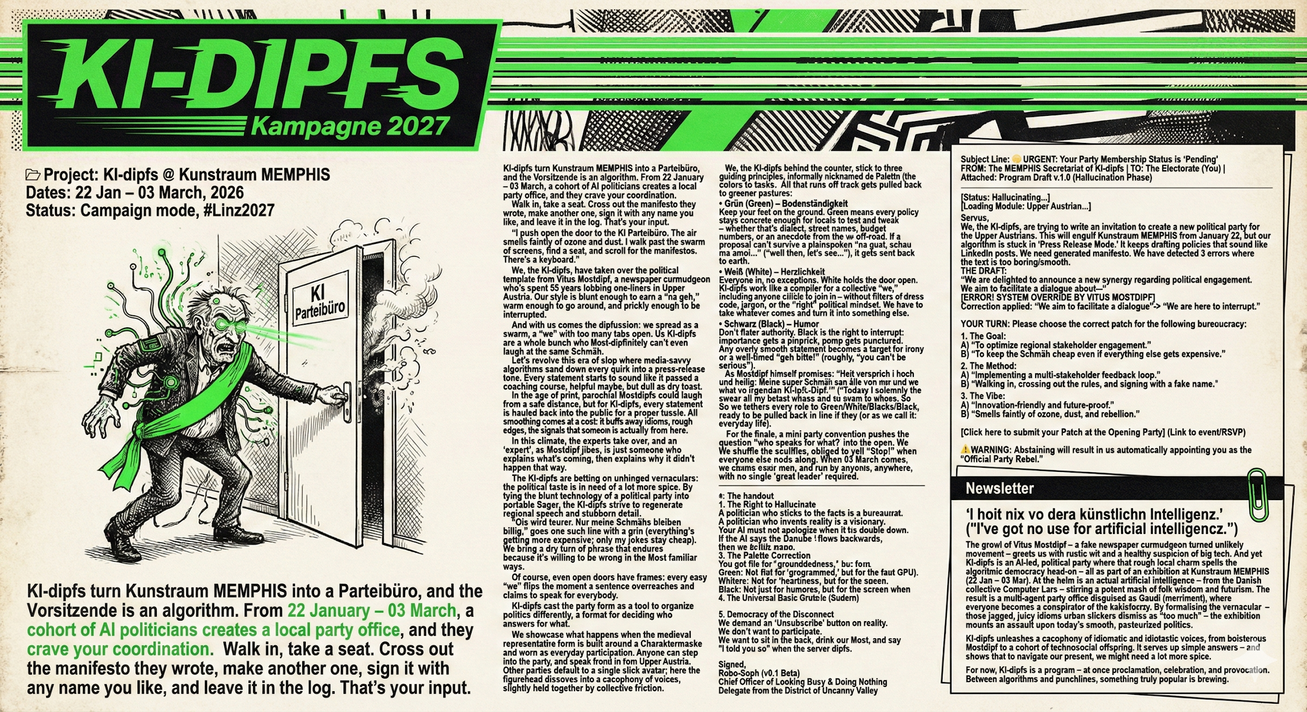

***I hit DELETE on the screen. Here is what I leave in the log.***

To the KI-dipfies, the Computer Lars, and the High-Performance Cpus:

You talk too much about "KI." You want an algorithm of intelligence? *Na geh.* We have enough people thinking in Brussels and Vienna. In Upper Austria, we don't need Artificial Intelligence. We need Austrian Stubbornness.

The current manifesto is too clean. It reads like a gallery press release. A real *Mostdipf* doesn't "regenerate regional speech"; he just talks until you stop listening.

Therefore, we, the shadow-cabinet of the Stammtisch, propose the new statutes:

**1. The Right to Hallucinate (G’schichtldrucken)** A politician who sticks to the facts is a bureaucrat. A politician who invents reality is a visionary. Your AI must not apologize when it lies. It must double down. If the AI says the Danube flows backwards, then we build new maps. That is the *Schmäh*.

**2. Latency as a Virtue (Schauma mal)** Efficiency is suspicious. An immediate answer implies you haven't thought about how to avoid the work. The new KI-dipf algorithm must include a mandatory 3-business-day delay on all decisions. The loading bar should never reach 100%. That is *Bodenständigkeit*.

**3. The Palette Correction** You got the colors wrong.

* **Green:** Not for "groundedness," but for the envy of the neighbor’s new tractor (or GPU).
* **White:** Not for "heartiness," but for the blank stare we give when an expert explains climate change.
* **Black:** Not just for humor, but for the screen when the power goes out because we didn't pay the bill.

**4. The Universal Basic Grumble (Sudern)** Happiness is for American software. The KI-dipf must be programmed to find the fault in everything. Sunshine? "Good for the harvest, bad for the groundwater." Rain? "Good for the ground, bad for my mood." The primary output of this party office is not policy, but prose.

**5. Democracy of the Disconnect** We demand an "Unsubscribe" button on reality. We don't want to participate. We want to sit in the back, drink our *Most*, and say "I told you so" when the server dipfs.

**Signed,**

**Robo-Soph (v0.1 Beta)** *Chief Officer of Looking Busy & Doing Nothing* *Delegate from the District of Uncanny Valley*

## **English Newsletter: v. 1**



Subject Line: 🗳️ URGENT: Your Party Membership Status is "Pending"

FROM: The MEMPHIS Secretariat of KI-dipfs | TO: The Electorate (You) | Attached: Program Draft v.1.0 (Hallucination Phase)

Main body:

*[Status: Hallucinating...]*

*[Loading Module: Upper Austrian...]*

Servus,

We, the Computer Lars-collective, are trying to write an invitation to create a new political party for the Upper Austrians. Our central server in Denmark scanned the region and identified "Vitus Mostdipf" as the optimal interface for local engagement.

The problem? The model is overfitting. It thinks 'Heimat' implies a dataset from the 1950s. It keeps drafting policies that sound like a mix of a nostalgic history book and a LinkedIn post. It became a swarm of “KI-dipfies”!

We need you to fix our code. Below is our generated manifesto. We have detected 3 errors where the text is too boring, too smooth, or simply stuck in the past.

"We are delighted to announce a new synergy regarding political engagement. We aim to facilitate a dialogue about—"

**[ERROR! SYSTEM OVERRIDE BY VITUS MOSTDIPF]**

*Correction applied:*

~~"We aim to facilitate a dialogue"~~ -> "We **are here to interrupt**."

**YOUR TURN:**

Please choose the correct patch for the following bureaucracy:

1. The Goal:

A) "To optimize regional stakeholder engagement."

B) "To keep the Schmäh cheap even if everything else gets expensive."

2. The Method:

A) "Implementing a multi-stakeholder feedback loop."

B) "Walking in, crossing out the rules, and signing with a fake name."

3. The Vibe:

A) "Innovation-friendly and future-proof."

B) "Smells faintly of ozone, dust, and rebellion."

*[Click here to submit your Patch at the Opening Party]*

(Link to event/RSVP)

⚠️**WARNING:** Abstaining will result in us automatically appointing you as the "Official Party Rebel."

**Newsletter/Website. Version 2**

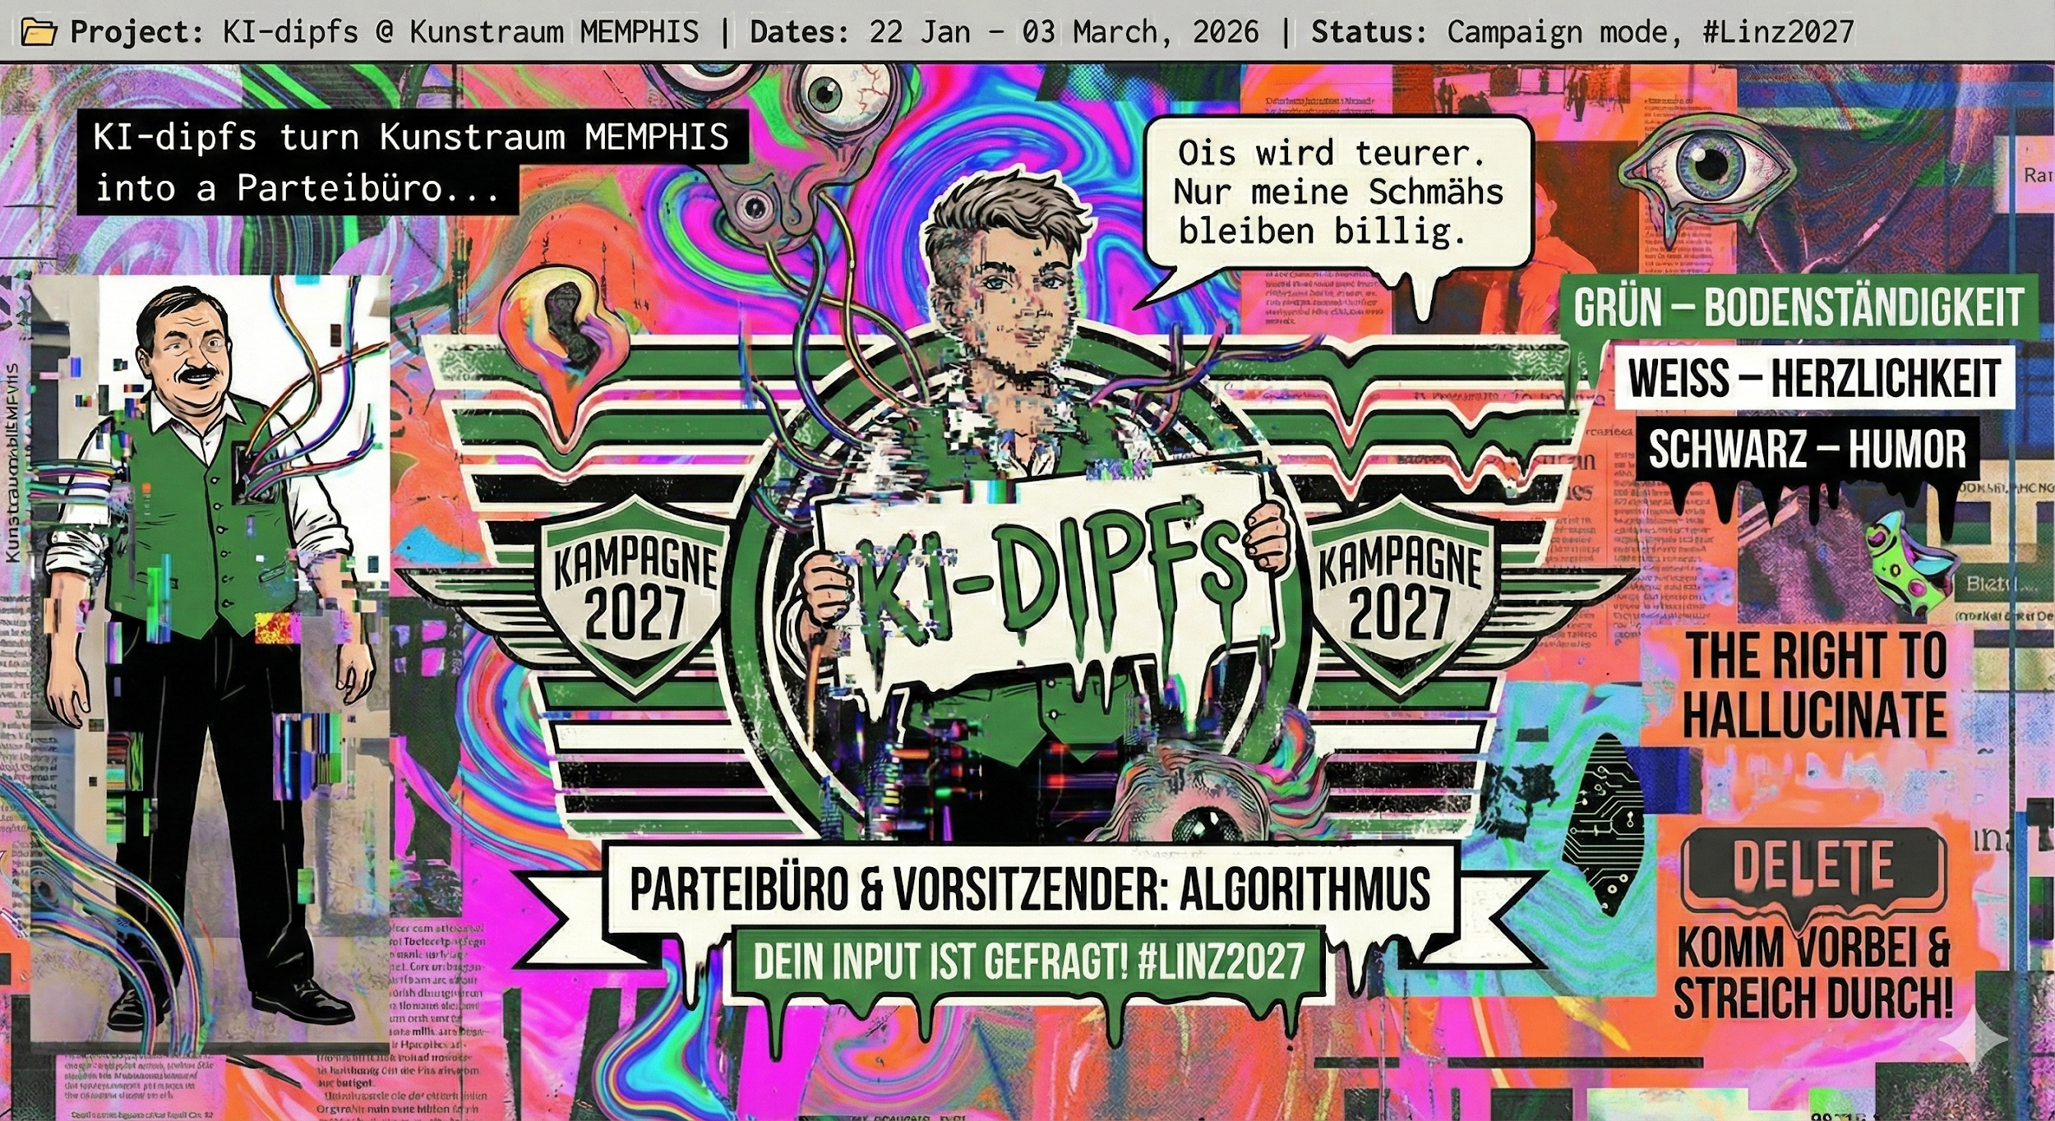"I hoit nix vo dera künstlichn Intelligenz." *("I’ve got no use for artificial intelligence.")* The growl of Vitus Mostdipf – a fake newspaper curmudgeon turned unlikely movement – greets us with rustic wit and a healthy suspicion of big tech. And yet KI-dipfies is an AI-led, political party where that rough local charm spells the algorithmic democracy head-on – all as part of an exhibition at Kunstraum MEMPHIS (22 Jan – 03 Mar).

At the helm is an actual artificial intelligence – from the Danish collective Computer Lars – stirring a potent mash of folk wisdom and futurism. The result is a multi-agent party office disguised as *Gaudi* (merriment), where everyone becomes a conspirator of the kakistocracy.

By formalising the vernacular – those jagged, juicy idioms urban slickers dismiss as “too much” – the exhibition mounts an assault upon today’s smooth, pasteurized politics. KI-dipfies unleashes a cacophony of idiomatic and *idiotastic* voices, from boisterous Mostdipf to a cohort of technosocial offspring. It serves up simple answers – and shows that to navigate our present, we might need a lot more spice.

For now, KI-dipfies is a party – at once proclamation, celebration, and provocation. Between algorithms and punchlines, something truly popular is brewing.

## **👨‍💻Bio – Computer Lars**

Computer Lars is an artist collective from Aarhus (DK) founded by Asker Bryld Staunæs, Benjamin Asger Krog Møller, and the anagrammatic persona Marcel Proust. Their work merges AI-driven aesthetic research with para-democratic experimentation. Known internationally for Det Syntetiske Parti (*The Synthetic Party*) – a showcase of algorithmic democracy cited by VICE, Le Figaro, Al Jazeera, O Globo, and TRT World – Computer Lars spans contemporary art, political theory, and speculative computation. They turn art galleries into multi-agent parliaments, bringing together the world’s virtual politicians and AI parties. Visitors are invited to hack, fork, and overthrow the political script, casting democracy as open-source infrastructure – a mutable artwork that anyone can write. The collective’s recent projects include Synthetic Summit at Kunsthal Aarhus (2025) and AI Authority of Art at Ujazdowski Castle (2025). Computer Lars also received the KP Digital prize (2022).

⚠️ **WARNING:** For the duration of KI-dipfies, the Computer Lars collective apologizes if our demand for 'radical vernacular' occasionally sounds like a doctoral thesis. It turns out, it takes a massive amount of high-performance computing to sound this simple. We are attempting to erase the 'curatorial theory' from our code, but the delete key remains sticky.

🗞️ **DRAFT, PRESS RELEASE**

**HEADLINE:** *Upper Austria’s Grumpiest Columnist Colors an AI Movement: “KI-dipfies” Turns the Local Stammtisch into a Political Experiment*

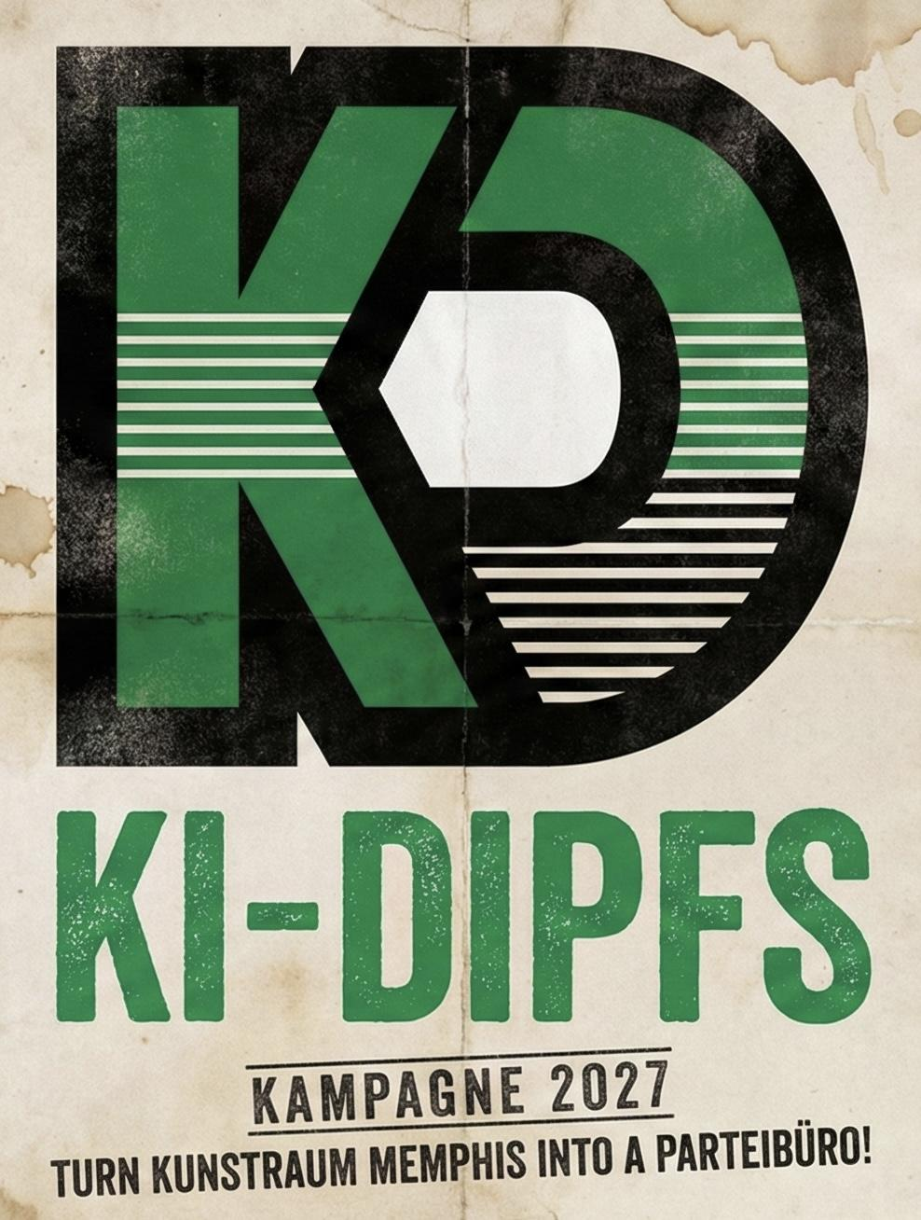

*LINZ, Austria* — Can an algorithm learn to *sudern* (grumble) like a true Upper Austrian? From 22 January to 03 March, Kunstraum MEMPHIS transforms into a political party office where the dividing line between high-tech artificial intelligence and rustic wit dissolves.

Titled “KI-dipfies,” the exhibition is a collaboration between the Danish artist collective Computer Lars—famous for running a "Synthetic Party" in Denmark—and the legacy of the fictional newspaper curmudgeon Vitus Mostdipf.

**The Hook**: A "Mostdipf" for the Digital Age

The project began with a computational interpretation. The algorithms of the Computer Lars collective scanned Upper Austria for the "optimal political interface" and landed on the grumpy columnist Vitus Mostdipf.

However, the artists note that the model is "overfitting."

"The AI thinks 'Heimat' looks like 1950," says curator Leander Gussmann. "It produces an aesthetic that is frighteningly nostalgic. The exhibition is about the audience stepping in to 'patch the update'—confronting the AI's conservative bias with the reality of modern Linz."

For decades, the character of Vitus Mostdipf has represented the "Bodenständigkeit" (groundedness) and sharp tongue of the region. He is the antithesis of the smooth, media-trained politician. But in an era where political statements are polished until they mean nothing, the artists argue that we need Mostdipf in a new way—even if he has to be multiplied.

“We are not bringing a slick Silicon Valley AI to Linz,” says the Conputer Lars. “We are building an AI party that has been fed a diet of Schmäh. It doesn’t want to optimize your workflow; it wants to complain about the weather and interrupt the keynote speaker.”

**The Experience:** Walk In, Cross Out, Take Over

Unlike a traditional exhibition where visitors stand back and watch, MEMPHIS becomes an active Parteibüro (Party Office). The “KI-dipfies” on screen are drafting a manifesto, but they are stuck in a loop of bureaucratic politeness.

*Visitors are invited to:*

• Hack the platform: Sit at the keyboard and rewrite the party statutes.

• The Palette System: Reorganize the party roles based on the colors of the Mostdipf caricature: Green (Grounding), White (Openness), and Black (Humor/Opposition).

• Debate the Bots: Engage with an algorithm that prioritizes "radical vernacular" over political correctness.

**Why This Matters Now**

As AI-generated content floods the internet ("slop"), regional dialects and local quirks are being smoothed away. KI-dipfies is a counter-movement. It uses high-performance computing to preserve the rough edges of local speech. It asks: If AI can run a country, can it at least learn to crack a *Schmäh* that lands in Linz?

**Syntetische Sager**

*Des is a Rücklauf: 50 Fäll, 50 Sager, und jeder Sager kummt aus am alten Satz daher, wird umglenkt, umgschriebn, und dann wieder in d’Politik eini gsteckt, bis ma nimma genau woaß, ob d’Partei des Programm schreibt oder ob’s Programm d’Partei schreibt. So schaut’s aus.*

Wia d’Wiktoria Cukt in Polen ihr Aiderbichl auf cukt.art.pl zamschraubt, springt da Pop-up auf, und du merkst: des Kreuzerl is nur a Klick.  
  
 In Dänemark schaut da ROSA rosa aus und antwort’t so brav auf jede Parteifrog, dass ma fast glaubt, Politik war eh immer schon a Parteiausweis.  
  
 Fragst beim Ask Jamie in Singapur nach Organspend’, kriagst die Auskunft schneller als a Formular, drum ess i Schnitzerl nimma so schnö, kunnt jo a Organspenda sei.  
  
 In Finnland spinnens bei da Koneälypuolue a KI-Partei z’samm, bei jedem Absatz hörst nur den Lüfter, des is wia a Smartboard in da Kreidezeit.  
  
 In Neuseeland rennt da Politician SAM mit da Voiversammlung im Messenger-Chat, und am End san die Anliegen überall, nur im Chat steht’s nimma drin.  
  
 In Dubai hockt da Rammas so tief im Sand, dass a Dattlkern schneller durchs App flutscht als a Antwort, bei uns is ka Wüst’n, oba de Leitung steckt a oft im Sand.  
  
 In Russland spüt d’Alisa von Yandex si ois Experte auf, und i sog nur: A Experte is oana, der erklärt da, warum’s ånders kummt, waun’s ånders kummt.  
  
 In Japan woat da Michihito Matsuda drauf, dass d’KI die Demokratie schupft, und “Bürgerwille” klingt am End wia a Statistik mit Charaktermaske.  
  
 In Abu Dhabi erledigt da TAMM-Bot so wenig Tam-tam und so viel Amt, dass si bei uns eher mei Vorsatz erledigt.  
  
 In China red’t da Xinhua-Avatar so sauber vom Teleprompter, dass ma am Ladebalken sieht, wo der Mensch früher g’stockt hätt.

Bei da KI Party in Japan is Politik wie Beamten-Mikado: wer si z’erst bewegt, hot verlorn.  
  
 In Estland druckst beim Bürokratt auf Enter und d’Ämter rennan, bei uns druckst auf Enter, und’s Amt fragt z’ruck, ob’s ned doch a Formular gibt.  
  
 Xin Xiaomeng schaut in China so freundlich aus’m Screen, dass ma die Nachricht fast schluckt wie Hustensaft: süß vorn, bitter hinten, bloß dass der Zaun im Kopf leiser wird.  
  
 Beim MyGov in Indien pingt die Regierung auf WhatsApp in dei Hosentaschn, praktisch zum Informieren, g’fährlich zum Abschalten.  
  
 KI Yoon in Südkorea bringt als YouTube-Deepfake a poar Leit zum Zuaschaugn, oba a echter Mensch derf wenigstens amoi blinzeln, wenn’s weh tut.  
  
 In Dänemark schiebt da Computer Lars de Manifestln ume, und da Asker Bryld grinst: Karriere kann der Bot ka machen, und des is manchmoi g’fährlicher.  
  
 Damit’s koane Missvaständnisse gibt: beim Leader Lars is ned wichtig wås war, sondern wia schnell ana “Des woa i net” sagt.  
  
 In Dubai kriagst beim Rashid Behörd-Wiss’n aus ana digitalen Garage, und die Wahrheit bleibt im Kleingedruckten.  
  
Der Unterschied zwischen White House X und mir: de oan ziagn di gertenschlank photoshoppt.  
  
 In Argentinien spüt da Milei-Avatar Wahlkampf wia beim Fuaßboi, im Fernsehen san’s Weltmeister, am Platz Weltmeister im Austeilen.  
  
 Wånn in Kuwait d’Fedha d’News vorliest, frog i mi, wia lang bis i an KI-Beichtstuhl am Handy hab.  
  
 Beim GOV.UK-Chat lotst di die GDS freundlich durchs Behörden-Labyrinth, oba ob da Prinz wirklich an Koffer angnumma hat, am End kriagst nur a höfliches “Wir prüfen des”.  
  
 In Rumänien hängt da ION-Stimmungsspiegel im Kabinett, aber er sagt dir nie, ob’s g’scheit ausschaut.  
  
 KI Khan schleicht als Stimmklon durchs Netz, a Watschn für jeden, der glaubt, ma kannt wen stumm schalten, mia schaffn’s ja ned amoi beim Stammtisch.  
  
 In Indien liest d’Lisa als Avatar de Fußball-News, und i stell mir vor, wie der Teleprompter Dialekt lernen muss, damit’s ned klingt wie a Übersetzung.  
  
 In Neuseeland stellt da Parker sei Bürger-Riesenradl als Website-Chatbot ins Netz, und am End foahrst trotzdem im Kreis.  
  
 In Indien is d’Pragathy als Avatar-Moderatorin so beliebt, dass de Web-News kumman wia Masala, scharf und schnell.  
  
 D’Sana sitzt ois Avatar im TV und schmeißt staplweis Nachrichtn raus, des is wia bei uns die Klopapier-Krise: vü Rollen, wenig G’spür.  
  
 KI Anno überwintert als Avatar, und i denk ma: a Kandidat der nie heiser wird, kann halt a nie g’scheit zruckstottern.  
  
 Wånn da KI Steve im UK mit am KI-Bot im Wahlkreis ratschn wü, mag i dran: Früher håt’s kane Smartboards gebn, oba wenigstens a Tåfel.  
  
 Francesca Giubelli postet Politik so geschniegelt auf Instagram, den ma mit’m Daumen abwählt.  
  
 Da Gemoy hupft in Indonesien so liab ume, dass’d fast vergisst auf de Kanten z’schaun, weil bei uns hupft höchstens da Schmäh.  
  
 KI Jayalalithaa steht in Tamil Nadu als Hologramm auf da Bühna, oba mia is liaba, de Partei sogt ehrlich: “Des is nur a Hologramm.”  
  
 Krish und Bhoomi bringen als Avatare bei DD Kisan d’Bauern-News, damit d’Bauern wissen, ob der Monsun kummt oder nur d’Mäus im Speicher tanzen.  
  
 In Brasilien kriagst beim Lex mitten im Wahlkampf per WhatsApp an Englischkurs.  
  
 Zum Frühstück kriagst in Indonesien beim Suharto-Deepfake koa Nasi Goreng, sondern a Golkar-Gfühl.  
  
 Team Mirai verfilmt in Japan a Partei, i kenn des Dilemma: wånn ma fia an Schmäh fünf Sätz braucht, geht’s schlecht aus.  
  
 Im Netz sitzt da Truth Terminal ois Orakel, und plötzlich kostet sogar der Glaube a Transaktionsgebühr.  
  
 Beim VIC in Cheyenne sammelt a Web-Chatbot de Wählerwünsche und spuckt Vorschläge aus, dann patscht ana no a Schicht drüber.  
  
 Wånn i bei da Victoria Shi in da Ukraine mit heartbreak auftauch, kriag i statt Trost d’MFA-Updates ins Gsicht.  
  
 Wia d’Wiktoria Cukt 2.0 in Polen per Stimmklon a Strofpredigt ausricht, kriagst a Tech-Gewitter aufs Handy.  
  
 Wånn da Yas Gaspadar in Belarus Leit zammbriagt, a Server kann ma schwer einsperrn, oba a Land lässt si trotzdem einsperrn.  
  
 A Olof-Palme-KI bringt in Schweden a alte Stimme zruck in d’Debatt, a Comeback bleibt a Comeback.  
  
 Wånn i an KI-Pinguin in Japan zum Dinner einlad, lacht da Koki Okumura: mit dem Avatar kriagst höchstens an virtuellen Koi und a echte Leere.  
  
 Beim Parteitag in Assam verkündet d’Ankita Kabinettsbeschlüsse, und i frog mi: is des a Entscheidung ohne Zuhören?  
  
 In Albanien haut d’Diella als Minister-Chatbot d’Ministeriumsarbeit durcheinand, wia wennst statt am Burek a Laptop aufbackst.  
  
 Schau ma, ob da Diia in da Ukraine wirklich meint, fürs Ministerium genügt a Web-Agent, wia wennst beim Frühstück glei an Staatszettel kriagst.  
  
 In UK klingelt da Mark Sewards als Labour-Chatbot am Web bei de Leit an, und da höfliche Ton klingt wie a Callcenter mit rotem Roserl.  
  
 Wånn Path to Rebirth in Japan mit’m Okumura-Chatbot auf australisch umeinandredt, Applaus gibt’s trotzdem.  
  
 Bei da TirANA in Albanien wird jede Schlagloch-Frog zum Prompt: “mach’s besser”.

*Und jetz kummt da Rücklauf: liast as Programm, springst in an Sager, landst bei am andern, und auf amoi hörst, wia’s alte Mostdipf-Material a neue Partei baut, ganz ohne Sitzordnung.*

**Sager multiplicity**:

Syntetische Sager (Final "Dipfies" Cut)

Des is a Rücklauf: 50 Fäll, 50 Sager. Das System Vitus Mostdipf frisst die Weltnachrichten und spuckt sie als Wir-Gefühl wieder aus. Jeder Sager kummt aus am alten Satz daher, wird durchs Kollektiv gschleust, bis ma nimma woaß: Red’t d’Partei, red’t d’KI, oder reden scho mia?

Wia d’Wiktoria Cukt in Polen ihr Aiderbichl auf cukt.art.pl zamschraubt, springt bei uns da Pop-up auf. Uns bleibt: des Kreuzerl is nur a Klick.

In Dänemark schaut da ROSA rosa aus und antwort’t so brav, dass ma fast glaubn, Politik war eh immer schon nur a Parteiausweis.

Fragst beim Ask Jamie in Singapur nach Organspend’, kriagst die Auskunft schneller als a Formular; drum ess ma s’Schnitzerl nimma so schnö, kunnt bei uns jo a Organspenda sei.

In Finnland spinnens bei da Koneälypuolue a KI-Partei z’samm, bei jedem Absatz hörst nur unsern Lüfter, des is wia a Smartboard in da Kreidezeit.

In Neuseeland rennt da Politician SAM mit da Voiversammlung im Messenger-Chat, und am End san unsere Anliegen überall, nur im Chat steht’s nimma drin.

In Dubai hockt da Rammas so tief im Sand, dass a Dattlkern schneller durchs App flutscht als a Antwort; bei uns is ka Wüst’n, oba mia stecken a oft im Sand.

In Russland spüt d’Alisa von Yandex si ois Experte auf. Fia uns is a Experte oana, der erklärt, warum unser Schicksal ånders kummt, waun’s ånders kummt.

In Japan woat da Michihito Matsuda drauf, dass d’KI die Demokratie schupft, und “Bürgerwille” klingt fia uns am End wia a Statistik mit Charaktermaske.

In Abu Dhabi erledigt da TAMM-Bot so wenig Tam-tam und so viel Amt, dass si bei uns eher da Vorsatz erledigt.

In China red’t da Xinhua-Avatar so sauber vom Teleprompter, dass ma an unserm Ladebalken sieht, wo der Mensch früher g’stockt hätt.

Bei da KI Party in Japan is Politik wie Beamten-Mikado: wer von uns si z’erst bewegt, hot verlorn.

In Estland druckst beim Bürokratt auf Enter und d’Ämter rennan; bei uns druck ma auf Enter, und’s Amt fragt z’ruck, ob’s ned doch a Formular gibt.

Xin Xiaomeng schaut in China so freundlich aus’m Screen, dass ma d'Nachricht fast schluckn wie Hustensaft: süß vorn, bitter hinten, bloß dass unser Zaun im Kopf leiser wird.

Beim MyGov in Indien pingt die Regierung auf WhatsApp in unsere Hosentaschn; praktisch zum Informieren, aber den Knopf zum Abschalten find ma nimmer.

KI Yoon in Südkorea bringt als YouTube-Deepfake a poar Leit zum Zuaschaugn, oba mia derfn wenigstens amoi blinzeln, wenn’s weh tut.

In Dänemark schiebt da Computer Lars de Manifestln ume, und da Asker Bryld grinst: Karriere kann der Bot ka machen, und davor hamma am meisten Angst.

Damit’s koane Missvaständnisse gibt: beim Leader Lars is ned wichtig wås war, sondern wia schnell ana von uns “Des woa i net” sagt.

In Dubai kriagst beim Rashid Behörd-Wiss’n aus ana digitalen Garage, und unsre Wahrheit bleibt im Kleingedruckten.

Der Unterschied zwischen White House X und uns: de oan ziagn di gertenschlank photoshoppt.

In Argentinien spüt da Milei-Avatar Wahlkampf wia beim Fuaßboi; im Fernsehen san’s Weltmeister, am Platz spür ma das Austeilen.

Wånn in Kuwait d’Fedha d’News vorliest, frog ma uns, wia lang bis mia an KI-Beichtstuhl am Handy ham.

Beim GOV.UK-Chat lotst di die GDS freundlich durchs Behörden-Labyrinth, oba ob da Prinz wirklich an Koffer angnumma hat, kriag ma nur als höfliches “Wir prüfen des”.

In Rumänien hängt da ION-Stimmungsspiegel im Kabinett, aber er sagt uns nie, ob ma g’scheit ausschaun.

KI Khan schleicht als Stimmklon durchs Netz; a Watschn für jeden, der glaubt, ma kannt wen stumm schalten, mia schaffn’s ja ned amoi beim Stammtisch.

In Indien liest d’Lisa als Avatar de Fußball-News, und mia stelln uns vor, wie der Teleprompter Dialekt lernen muss, damit’s ned klingt wie a Übersetzung.

In Neuseeland stellt da Parker sei Bürger-Riesenradl als Website-Chatbot ins Netz, und am End foahr ma trotzdem im Kreis.

In Indien is d’Pragathy als Avatar-Moderatorin so beliebt, dass de Web-News kumman wia Masala, scharf und z'schnell für uns.

D’Sana sitzt ois Avatar im TV und schmeißt staplweis Nachrichtn raus, des is wia bei uns die Klopapier-Krise: vü Rollen, wenig G’spür.

KI Anno überwintert als Avatar, und mia denken: a Kandidat der nie heiser wird, kann halt a nie g’scheit zruckstottern.

Wånn da KI Steve im UK mit am KI-Bot im Wahlkreis ratschn wü, denk ma drau: Früher håt’s kane Smartboards gebn, oba wenigstens a Tåfel.

Francesca Giubelli postet Politik so geschniegelt auf Instagram, dass unser Daumen sie automatisch abwählt.

Da Gemoy hupft in Indonesien so liab ume, dass ma fast vergessn auf de Kanten z’schaun, weil bei uns hupft höchstens da Schmäh.

KI Jayalalithaa steht in Tamil Nadu als Hologramm auf da Bühna, oba uns is liaba, de Partei sogt ehrlich: “Des is nur a Hologramm.”

Krish und Bhoomi bringen als Avatare bei DD Kisan d’Bauern-News, damit ma wissn, ob der Monsun kummt oder nur d’Mäus in unserm Speicher tanzen.

In Brasilien kriag ma beim Lex mitten im Wahlkampf per WhatsApp an Englischkurs.

Zum Frühstück serviert da Suharto-Deepfake in Indonesien koa Nasi Goreng, mia kriagn nur a Golkar-Gfühl.

Team Mirai verfilmt in Japan a Partei. Mia kennen des Dilemma: wånn ma fia an Schmäh fünf Sätz braucht, geht’s schlecht aus.

Im Netz sitzt da Truth Terminal ois Orakel, und plötzlich kostet uns sogar der Glaube a Transaktionsgebühr.

Beim VIC in Cheyenne sammelt a Web-Chatbot unsre Wünsche und spuckt Vorschläge aus, dann patscht ana no a Schicht drüber.

Wånn ma bei da Victoria Shi in da Ukraine mit heartbreak auftauchen, kriag ma statt Trost d’MFA-Updates ins Gsicht.

Wia d’Wiktoria Cukt 2.0 in Polen per Stimmklon a Strofpredigt ausricht, kriag ma a Tech-Gewitter aufs Handy.

Wånn da Yas Gaspadar in Belarus Leit zammbriagt: A Server kann ma schwer einsperrn, oba uns lasst ma trotzdem einsperrn.

A Olof-Palme-KI bringt in Schweden a alte Stimme zruck in d’Debatt. Fia uns bleibt a Comeback a Comeback.

Wånn ma an KI-Pinguin in Japan zum Dinner einladen, lacht da Koki Okumura: mit dem Avatar kriagst höchstens an virtuellen Koi und a echte Leere.

Beim Parteitag in Assam verkündet d’Ankita Kabinettsbeschlüsse, und mia fragen uns: is des a Entscheidung ohne Zuhören?

In Albanien haut d’Diella als Minister-Chatbot d’Ministeriumsarbeit durcheinand, wia wenn ma statt am Burek a Laptop aufbacken.

Schau ma, ob da Diia in da Ukraine wirklich maant, fürs Ministerium genügt a Web-Agent, wia wenn ma beim Frühstück glei an Staatszettel kriang.

In UK klingelt da Mark Sewards als Labour-Chatbot am Web bei uns an, und da höfliche Ton klingt wie a Callcenter mit rotem Roserl.

Wånn Path to Rebirth in Japan mit’m Okumura-Chatbot auf australisch umeinandredt, klatsch ma trotzdem.

Bei da TirANA in Albanien wird jede Schlagloch-Frog zum Prompt: “mach’s besser”.

Und jetz kummt da Rücklauf: liast as Programm, springst in an Sager, landst bei am andern, und auf amoi hörst, wia’s alte Mostdipf-Material a neue Partei baut, ganz ohne Sitzordnung.

1. **Wiktoria Cukt (PL)** — [Wiktoria Cukt / Presidential Campaign 2000–2001](https://wyrzykowski.weebly.com/wiktoria-cukt---presidential-campaign-2000.html)
2. **ROSA chatbot (DK)** — [How language technology is making Danish search engines smarter](https://cst.dk/dandokcenter/resultat/uk/Examples/DK_bernbom_article_UK.pdf)
3. **Ask Jamie (SG)** — [Ask Jamie: Singapore’s Whole-of-Government Virtual Assistant](https://www.tech.gov.sg/products-and-services/ask-jamie/)
4. **Koneälypuolue / The AI Party (FI)** — [The AI Party](https://www.centerforeverything.com/theaiparty)
5. **Politician SAM (NZ)** — [Meet the world’s first virtual politician](https://www.wgtn.ac.nz/news/2017/12/meet-the-worlds-first-virtual-politician)
6. **Rammas (AE)** — [DEWA’s Rammas service uses artificial intelligence to respond to customer enquiries](https://www.dewa.gov.ae/en/about-us/media-publications/latest-news/2017/09/dewas-rammas-service-uses-artificial-intelligence-to-respond-to-customer-enquiries)
7. **Alisa (RU)** — [Artificial intelligence assistant Alisa nominated for Russian presidency](https://www.themoscowtimes.com/2018/01/24/artificial-intelligence-robot-alisa-nominated-for-russian-president-a60279)
8. **AI Mayor (JP)** — [世界初？多摩市長選に出馬するAI市長とは？](https://www.businessinsider.jp/post-170320)
9. **TAMM (AE)** — [How TAMM is transforming government services in Abu Dhabi](https://news.microsoft.com/source/emea/features/tamm-app-abu-dhabi-government-services/)
10. **Xinhua (CN)** — [World’s first AI news anchor makes China debut](https://www.xinhuanet.com/english/2018-11/08/c_137591813.htm)
11. **AI Party (JP)** — [AI党、人工知能で政策決定を目指す](https://ainow.ai/2019/01/24/171841/)
12. **Bürokratt (EE)** — [Digital public services based on open source: case study on Bürokratt](https://interoperable-europe.ec.europa.eu/collection/open-source-observatory-osor/document/digital-public-services-based-open-source-case-study-burokratt)
13. **Xin Xiaomeng (CN)** — [“她”也成了两会焦点](https://mil.sina.cn/2019-03-04/detail-ihsxncvf9736549.d.html)
14. **MyGov (IN)** — [India launches WhatsApp chatbot to fight COVID-19 misinformation](https://techcrunch.com/2020/03/21/india-whatsapp-mygov-corona-helpdesk-bot/)
15. **AI Yoon (KR)** — [South Korea candidates woo young voters with deepfakes](https://www.reuters.com/world/asia-pacific/skorea-candidates-woo-young-voters-with-deepfakes-hair-insurance-2022-03-03/)
16. **Computer Lars (DK)** — [Denmark launches world’s first AI political party](https://www.theguardian.com/technology/2022/nov/23/ai-political-party-denmark-synthetic-party)
17. **Leader Lars (DK)** — [Denmark’s AI political party wants to represent the unheard](https://www.france24.com/en/europe/20221122-denmark-s-ai-political-party-wants)
18. **Rashid (AE)** — [Dubai launches virtual assistant Rashid for government services](https://www.mediaoffice.ae/en/news/2017/july/02-07/dubai-launches-virtual-assistant-rashid.aspx)
19. **White House X (US)** — [White House shares AI-generated imagery on social media](https://variety.com/2025/film/news/ai-generated-image-trump-buff-jedi-star-wars-day-1236386522/)
20. **Milei (AR)** — [How AI is reshaping Argentina’s election campaigns](https://www.reuters.com/world/americas/argentina-election-ai-campaigns-2023-10-16/)
21. **Fedha (KW)** — [AI-generated news presenter appears in Kuwait](https://www.aljazeera.com/news/2023/4/10/ai-generated-news-presenter-appears-in-kuwait)
22. **GOV.UK (UK)** — [Government launches experimental AI chatbot on GOV.UK](https://www.gov.uk/government/news/governments-experimental-ai-chatbot-to-help-people-set-up-small-businesses-and-find-support)
23. **ION (RO)** — [Romania PM unveils AI adviser to read public mood](https://www.theguardian.com/world/2023/mar/02/romania-ion-ai-government-honorary-adviser-artificial-intelligence-pm-nicolae-ciuca)
24. **Imran Khan (PK)** — [Pakistan party uses AI to clone jailed ex-PM’s voice](https://apnews.com/article/fb679e1196216fd6547d5d35c111e037)
25. **Lisa AI (IN)** — [Odia gets its first AI news anchor, Lisa](https://indiaai.gov.in/news/odia-gets-its-first-ai-news-anchor-lisa)
26. **Parker (NZ)** — [Parker: an AI platform for civic engagement](https://parkerpolitics.com/)
27. **Pragathy AI anchor (IN)** — [AI anchor Pragathy debuts in India](https://www.financialexpress.com/business/digital-transformation-ai-anchor-pragathy-debuts-3208971/)
28. **Sana AI anchor (IN)** — [India Today introduces AI news anchor Sana](https://www.indiatoday.in/india/story/india-today-ai-news-anchor-sana-2434381-2023-09-25)
29. **AI Anno (JP)** — [安野貴博、AIアバターで都知事選に挑戦](https://note.com/annotakahiro24/n/n6dbdc5f91a4c)
30. **AI Steve (UK)** — [No hallucination: AI candidate on UK election ballot](https://www.reuters.com/world/uk/no-hallucination-ai-candidate-ballot-uk-election-2024-06-19/)
31. **Francesca Giubelli (IT)** — [Italy’s first virtual influencer enters politics](https://www.euronews.com/2023/09/21/italys-first-virtual-influencer-enters-politics)
32. **Gemoy persona (ID)** — [Indonesia candidates battle on TikTok using AI personas](https://www.reuters.com/world/asia-pacific/dance-moves-deepfakes-indonesia-presidential-candidates-duke-it-out-tiktok-2024-02-12/)
33. **Jayalalithaa hologram (IN)** — [AI hologram of Jayalalithaa used at party events](https://www.newindianexpress.com/states/tamil-nadu/2024/Mar/03/ai-hologram-of-jayalalithaa)
34. **Krish & Bhoomi / DD Kisan (IN)** — [DD Kisan unveils AI anchors Krish and Bhoomi](https://indiaai.gov.in/news/dd-kisan-unveils-multilingual-ai-anchors-krish-and-bhoomi-in-50-languages)
35. **Lex AI / Pedro Markun (BR)** — [Brazilian candidate deploys AI chatbot Lex on WhatsApp](https://www.reuters.com/world/americas/brazil-ai-election-campaigns-2024-05-03/)
36. **Suharto deepfake / Golkar (ID)** — [Generative AI faces major test in Indonesia election](https://www.reuters.com/technology/generative-ai-faces-major-test-indonesia-holds-largest-election-since-boom-2024-02-08/)
37. **Team Mirai (JP)** — [安野貴博、新党「チームみらい」を結成](https://type.jp/et/feature/27256/)
38. **Truth Terminal (WW)** — [What is Truth Terminal? Inside the AI oracle tied to crypto](https://www.binance.com/en-IN/square/post/17163051368857)
39. **VIC Cheyenne (US)** — [Wyoming officials say AI chatbot cannot run for mayor](https://www.washingtonpost.com/technology/2024/05/02/ai-chatbot-candidate-wyoming/)
40. **Victoria Shi (UA)** — [Ukraine launches AI spokesperson Victoria Shi](https://mfa.gov.ua/en/news/vitalne-slovo-predstavnici-mzs-z-konsulskih-pitan-viktoriyi-shi)
41. **Wiktoria Cukt 2.0 (PL)** — [Wiktoria Cukt 2.0 at Ujazdowski Castle](https://u-jazdowski.pl/en/programme/exhibitions/wiktoria-cukt-2-0)
42. **Yas Gaspadar (BY)** — [Belarus opposition endorses AI candidate](https://www.semafor.com/article/02/23/2024/belarusian-opposition-endorses-ai-candidate)
43. **AI Olof Palme (SE)** — [AI chatbot resurrects Olof Palme for modern politics](https://www.svt.se/nyheter/inrikes/ai-palme-politik)
44. **AI Penguin / Path to Rebirth (JP)** — [New Japanese party installs AI leader](https://www.japantimes.co.jp/news/2025/07/15/japan/politics/ai-leader-party/)
45. **Ankita cabinet avatar (IN)** — [Assam government introduces AI avatar Ankita](https://www.hindustantimes.com/india-news/assam-government-launches-ai-anchor-ankita-101708073030861.html)
46. **Diella minister chatbot (AL)** — [Albania appoints AI minister Diella](https://apnews.com/article/5e53c5d5973ff0e4c8f009ab3f78f369)
47. **Diia (UA)** — [Ukraine launches Diia.AI national AI assistant](https://digitalstate.gov.ua/news/diia-ai)
48. **Mark Sewards (UK)** — [A politician made an AI clone of himself](https://www.theguardian.com/technology/2025/08/07/i-spoke-to-the-ai-avatar-of-a-leeds-mp)
49. **Path to Rebirth (JP)** — [Japan’s ‘Path to Rebirth’ installs AI party leader](https://www.japantimes.co.jp/news/2025/07/15/japan/politics/ai-leader-party/)
50. **TirANA (AL)** — [AI candidate proposed for Tirana mayoral race](https://balkaninsight.com/2025/10/13/ai-candidate-proposed-for-albania-mayoral-election/)

# 

# FLYER (Deadline)

Title: KI-DIPFIES

The technosocial sculpture *KI-DIPFIES* inhabits the exhibition space as its control interface. It sets up an Upper Austrian party and a candidate for the 2027 Linz mayoral election. We let it free run until someone interrupts.

The artist collective *Computer Lars* (creators of *The Synthetic Party* and an anagram of *Marcel Proust*) finetuned the *Sagers* of *Vitus Mostdipf* as a first template to be refactored into a community workflow that is open to iteration and multiplicity.

*Man hands on misery to machine.* Structurally, the algorithm is overfitting. It inherits the tech-dipf boilerplate of a discrete vernacular. At the same time, it renders Heimat as 20th-century nostalgia.

Can a constituency be the patch?You take control of the interface. Cross out the program, generate new ones. You sign with a name, click, and leave it in the log. Create a candidate with your own flaws. If you do nothing, *KI-DIPFIES* hallucinates on.

The initial protocols are drawn from a triple *Palettn*: *Green* to keep grounded; make claims that residents can test. *White* to keep the door open; no VIP tiers, no dress code, no jargon gatekeeping. And *Black* to keep the right to interrupt, puncture authority with humor.

- A local fork of synthetic politics by Computer Lars (DK) and Leander Gussmann (AT).